LINUX COMMANDS
- ls command:

What it is:
ls shows the contents of a directory (files and folders).

Why it is used:
It helps users see what files and directories are present in a directory.

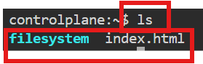
- touch command:

What it is:
touch creates a new empty file if it does not exist.

Why it is used:
To quickly create a file. To update access and modification time of a file

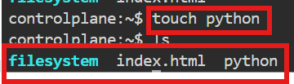
- vi command:

What it is:
vi is a text editor available in Unix/Linux systems.

Why it is used:
To create or edit files from the terminal. Commonly used to edit configuration files and scripts.
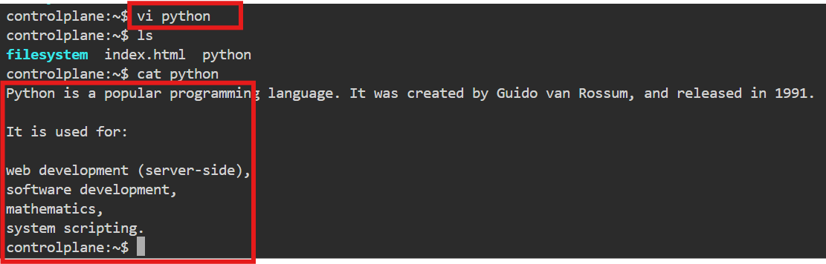
Exit commands:
Used for after inserting the any text
:w → save
:q → quit
:wq → save and quit
:q! → quit without saving

- Cat command:

What it is:
- cat stands for concatenate.
Why it is used:
    - To view the contents of a file
    - To create a file
    - To merge multiple files into one

- Nano command:

What it is:
nano is a simple, user-friendly text editor in the terminal.
Why it is used:
- Easy to use for beginners
- Quickly edit configuration files and scripts
- No complex modes like vi
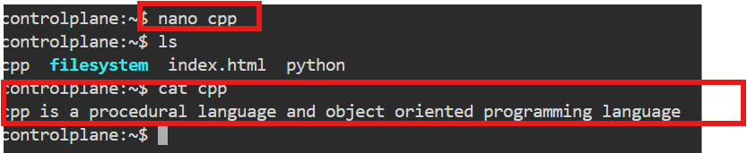

Common Nano shortcuts:

- Ctrl + O → Save
- Ctrl + X → Exit
- Ctrl + K → Cut line
- Ctrl + U → Paste line

- Mkdir command:
What it is:
mkdir stands for make directory.
Why it is used:
      - To create new folders
      - To organize files and directories
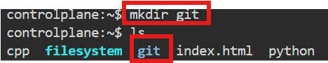
- mv command:
What it is:
mv stands for move.

Why it is used:
- To move files/directories from one location to another
- To rename files or folders

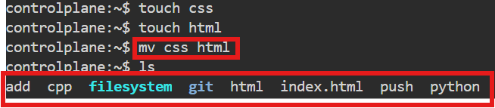
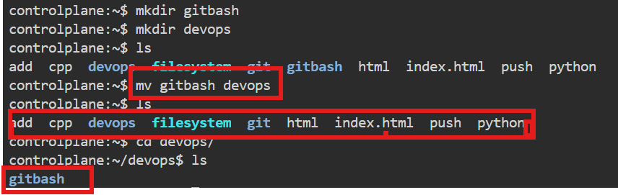

- Cd command:

What it is:
cd stands for change directory.

Why it is used:
- To navigate between directories
- To move to a specific folder location

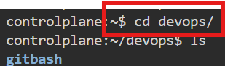

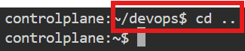
- Pwd command :

What it is:
pwd stands for print working directory.
Why it is used:

- To know your current location in the filesystem
- Helps avoid confusion while navigating directories
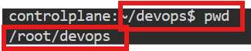
- rmdir command:

What it is:
rmdir stands for remove directory.
Why it is used:

- To remove directories that are empty
- Helps clean up unused folders

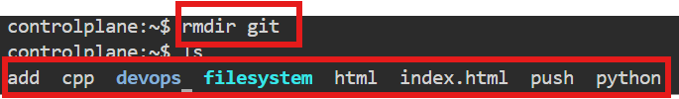

- Rm command:
What it is:
rm stands for remove.
Why it is used:
- To delete files
- To delete directories (with options)
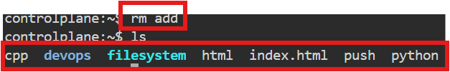

- Copy command:

What it is:
cp stands for copy.

Why it is used:
- To duplicate files
- To copy files or folders from one location to another

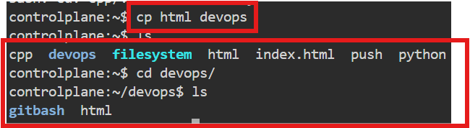

- wget command:

wget stands for web get.
Why it is used:

- To download files using a URL
- Works in the background
- Commonly used to download software, packages, or data
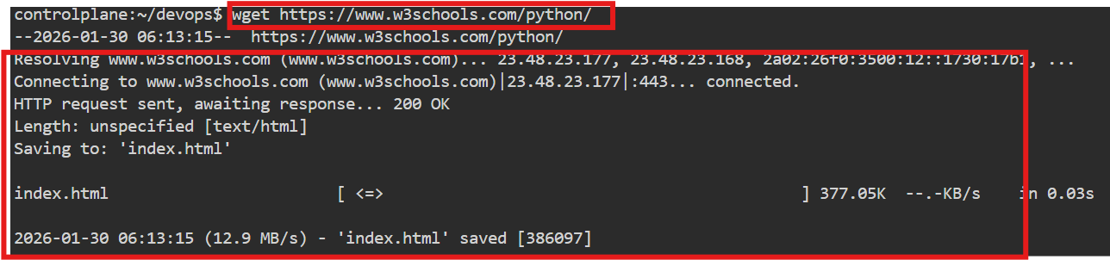
- Ping command:

The ping command is a network utility used to test the reachability of a host (like a server or website) on a network and measure the round-trip time for messages sent from your computer to that host. It’s available on Windows, Linux, and macOS.

